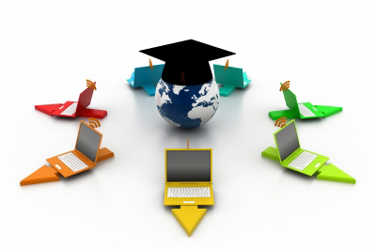

Understanding the Implication of

Online Education in US

## Maharishi University of Management

**Business Intelligence and Data Mining**

Professor Anil K. Maheshwari, Ph.D.

May 2014

Hardi Chandra

Joy Kareen Landicho

Zeina Rawashdeh

Bharat Kurma

Manish Kaur

Robera Aberra

## Table of Contents

1. **Wholeness of the Project** ……………………………………………………………. 1
2. Introduction ……………………………………………………………………… 1
3. Objectives ……………………………………………………………………… 1
4. Research Questions ……………………………………………………………. 2
5. Project Tools ……………………………………………………………………… 2
6. Project Timeline ……………………………………………………………. 3
7. Project Schedule ……………………………………………………………. 3
8. **Literature Review** ……………………………………………………………………… 4
9. **Research Hypothesis** ……………………………………………………………. 9
10. **Data & Research Methodology** ……………………………………………………… 10
11. Data Source ……………………………………………………………………… 10
12. Data Cleansing ……………………………………………………………………. 11
13. Data Analysis Techniques ……………………………………………………….. 11
14. **Findings / Interpretation** ……………………………………………………………… 12
15. **Conclusion / Limitation** …………………………………………………………… 15
16. **Options for Future Research** …………………………………………………………. 17
17. **Relationship with Science of Creative Intelligence** …………………………….. 18

## Part I

## Wholeness of the Project

## Introduction

Since the internet was founded in 1989 and became famous, all areas in this world have been reaching its next step. Education is one of those areas that improve a lot with the use of internet. This technology strengthens the education and improves by giving people something called Online Education where students doesn't have to come to class and meet face to face with the lecturer anymore. They can just learn from their home or everywhere as long as they have internet connection. This condition is even getting better where the concept called Massive Open Online Course (MOOC) was founded. With MOOC, we can have unlimited participation and all the materials, from the lectures, problem sets, readings, etc. Everything is accessible via the web. Most of the courses are even given freely to whoever wants to study, and even better, they even give free certificate for finishing the free online course.

With its entire feature and all its benefit for the past years, online education enrollment has been growing a lot faster than traditional education enrollment. In our research, we will try to compare the implication and correlation between the growth of Online Education against some variables, such as the traditional education enrollment, economy, international student enrollment, employment/unemployment and internet use at home.

## Objectives

The objective of this research is to find out what is the impact of growth in online education, against some of the other variables, such as the traditional face-to-face education enrollment, economic development, number of international students, employment/unemployment rate and computer/internet use at home. From these objectives we will know whether Online Education will change how education will work in the future. It might even replace traditional face to face education or it might be the opposite, the growth will be stopping and it will just vanish because of some factor. With this research we will know what are the prediction and the possible result outcome.

Using the publicly available datasets in the web, we will make use of and apply the business intelligence concepts and data mining techniques to achieve these objectives.

## Research Questions

The research question that we propose was some correlation between the growth in online education and other variables.

* **Does the continuous growth of Online Education has any impact on:**

1. **Traditional face-to-face Education**

**Since online education grows very fast,** will this growth have any impact for the traditional education**? Will it going to overtake or even replace the traditional face-to-face education in the near future?**

1. **Economic Development**

Because of the flexibility offered by online learning, people are able to get more educational attainability to meet business need and learning demands. Will it going to help the economy to make it grows faster?

1. **Enrollment Number of International Student**

**Since online education is convenient and accessible everywhere with the internet, will it reduce the enrolment rate of international student? Will they prefer staying at their home country and take the online education program?**

* **Does Online Education has any relation with:**

1. **Employment / Unemployment Rate**

**Since the people are getting education that is cheaper and even free e through the online learning, will it contribute to employment rate and address the issues of unemployment?**

1. **Increase of Internet Use at Home**

**Online learning is available everywhere with internet,** would this lead to the growth of household computer and internet usage?

## Project Tools

**Data Analysis Tools**

Microsoft Excel – used as initial container of the data to be loaded to SPSS and also to perform some basic analysis and draw out some graphs from it

SPSS – an analytic software tool used for the main analysis of data

**Group Communication Tools**

Facebook Messenger – an instant messaging app used for our group discussion

Google Drive – an online file storage service used for document keeping and sharing

## Project Timeline

|  |  |  |  |  |
| --- | --- | --- | --- | --- |
| **Project Tasks** | **Number of Member** | **Schedule** | **Estimated Work Time (Hours)** | **Description** |
| **Completing Exploratory Research** | 6 | Week 1 | 10 | Doing the research about the question that the group's going to search and find the right datasets. |
| **Finalize the research Question** | 6 | Week 1 | 10 | Finalizing the question after doing the research about the question |
| **Downloading datasets** | 1 | Week 1 | 5 | Download the source dataset that is going to be analyzed |
| **Preparing datasets** | 2 | Week 2 | 10 | Cleansing the datasets that is being downloaded. |
| **Initial analysis and interpretations** | 6 | Week 2 | 30 | Do the basic analysis and the interpretations we can find with the datasets |
| **Completing Full Analysis** | 6 | Week 3 | 20 | Do the bigger scale analysis to answer the questions or even find the new hidden pattern |
| **Completing Research Findings** | 6 | Week 3 | 25 | Finalizing the analysis and wrap up the findings |
| **Writing the report** | 3 | Week 3 & 4 | 15 | Write the report about the source and the results of the analysis |
| **Creating the presentation** | 3 | Week 4 | 10 | Make the presentation and prepare to present to the class |

## 

## Project Schedule

## Part II

## Literature Review

For the literature review, we browse a lot of articles to find more about the impact of Online Education. These are some literatures and articles that we reviewed and also become source of some of our data for this research topic.

1. **Title: Grade Change : Tracking Online Education in the United States**

**Authors:** I. Elaine Allen and Jeff Seaman

**Publisher:** BABSON Survey Research Group

**Description:**

This article is a very great resource about the future of online learning. They give you the growth of the online learning which was tremendous compared to the total enrollment. They also compare the outcomes of online learning which is 74% same or superior outcome rather than face-to-face education in 2013. They also discuss the future of online learning and MOOC.

1. **Title: Online College Students 2013 : Comprehensive Data on Demands and Preferences**

**Authors:** Carol B. Aslanian and Dr. David L. Clinefelter

**Publisher:** The Learning House Inc. and Aslanian Market Research

**Description:**

This article is a very powerful resource about the online education in 2013. This article give us information about the distribution in level of education for people who attends online course, the field of study for each level, and also the distribution of people who only wants certificate/license. It also presents the factors that drive people to choose or not to choose online courses in specific institution. It also provides powerful information that we need for our research.

1. **Title: Learning at a Distance : Undergraduate Enrollment in Distance Education Courses and Degree Program**

**Authors:** Alexandria Walton Radford and Thomas Welko

**Publisher:** MPR Associates, inc. and National Center for Education Statistics

**Description:**

This is a really good article about the “2007-2008 Undergraduate Online Education” study. In this article they have precise findings that from 2000 to 2008, the number of students that enrolled for online course has increased by 12% where the major increases are happening on Computer Science and Business area of study. This survey also concludes that online education courses are dominated by age group 30 or older.

1. **Title: Are open education resources the key to global economic growth**

**Authors:** Sir John Daniel and David Killion

**Source:** [www.theguardian.com](http://www.theguardian.com)

**Description:**

The article was talking about Open Education Resources (OER), which could be the key to handle global education crisis and to open sustainable growth. OER can help students more than $40 million dollar each year and it also can help university's marketing cost. This OER is very powerful and more and more university is joining this OER, which is currently famous with term MOOC.

1. **Title: 4 Online Education Program Considerations for International Students**

**Authors:** Katy Hopkins

**Publisher:** US News & World Report

**Source:** <http://www.usnews.com/education/online-education/articles/2013/01/16/4-online-education-program-considerations-for-international-students>

**Description:**

This article from US News discussed about how online education is an attractive option for an international student because this technology allows them to study in US while working in their home country to pay for the tuition fee. It also provides 4 considerations for the international student before committing to online degree to ensure that it is a right move.

1. **Title: Study: Online Learning Outcomes Similar to Classroom Results**

**Authors:** Ryan Lytle

**Publisher:** US News & World Report

**Source:** <http://www.usnews.com/education/online-education/articles/2012/07/25/study-online-learning-outcomes-similar-to-classroom-results>

**Description:**

This study from US News discussed about the comparison of online learning to traditional in-class instruction as some critics of online learning claim that students are more exposed to inferior education. The report notes that students who utilize interactive online learning—or hybrid learning—produce equivalent, or better, results than students participating in face-to-face education.

1. **Title: Interactive Learning Online at Public Universities: Evidence from Randomized Trials**

**Authors:** William G. Bowen, Matthew M. Chingos, Kelly A. Lack, Thomas I. Nygren

**Publisher:** ITHAKA S+R

**Source:** <http://www.usnews.com/education/online-education/articles/2013/01/16/4-online-education-program-considerations-for-international-students>

**Description:**

This article from ITHAKA S+R, a research and consulting service, measure the effect on learning outcomes of a prototypical interactive learning online (ILO) statistics course. It also evaluates and justifies the cost and potential savings of online education over the traditional face-to-face education with evidence from randomized trials.

1. **Title: Will Online Learning Replace the Classroom?**

**Authors:** Avi Yashcin

**Source:** [www.huffingtonpost.com](http://www.huffingtonpost.com)

**Description:**

A really nice article about the possibility of online learning to replace the classroom education. MOOC has really shown a really promising growth that even 2U, an online education company has filing to raise up to $100 million for this area. According to this article, online education still has a long way to go to replace the classroom, but it's not impossible since 69.1 % of chief academic officer says that online learning plays a critical part of their long term strategy. And with the growth of MOOC, such as Udacity, Coursera, Edx, etc. which is really big.

1. **Title: Can MOOCs and Universities Co-Exist?**

**Authors:** Douglas Belkin

**Publisher:** Wall Street Journal

**Description:**

A really nice article that asked some professor about their opinion of whether MOOC will replace classroom learning in the future. Most of the Professor that is answering the question was saying that MOOC will not be able to overtake classroom learning, but it's a really a newly forming market that grows really fast and can help basically everyone to learn something for free. So this is a new kind of education that really has a potential to become something big, and change the education in the entire world.

1. **Title: Examining the Effectiveness of Online Learning Within a Community College System: An Instrumental Variable Approach**

**Authors:** Di Xu & Shanna Smith Jaggars

**Publisher:** ITHAKA S+R

**Source:** <http://www.edweek.org/dd/articles/2012/02/08/02research.h05.html>

**Description:**

This is a good research topic raised on how effective online education is. Using a large administrative dataset from a state-wide community college system, the authors employed an instrumental variable technique to estimate the impact of online versus face-to-face course delivery on student course performance, as indicated by course persistence and final course grade.

1. **Title: Studying the Long-Term Effects of Online Education**

**Authors:** Stephen Abram

**Source:** <http://stephenslighthouse.com/2013/03/14/studying-the-long-term-effects-of-online-education/>

**Description:**

The article talk about the growth in online education and how it change the way people approach learning and permanent impact of few things along the way, it talk about the cost of enrolment in online course comparing with enrollment in traditional educational institution, also it talk about the result of each approach and it mentioned that best outcome comes from merging both.

1. **Title: Down Economy Drives Online Learning: Enrollment Jumped 17 Percent in 2009**

**Publisher:** ABC News

**Source:** <http://abcnews.go.com/blogs/lifestyle/2010/02/down-economy-drives-online-learning-enrollment-jumped-17-percent-in-2009/>

**Description:**

The article talk about impact of economy on education demand, While the economy has led to an increased demand for college courses in general, the economic impact has been greatest on demand for online courses, Among the institutions surveyed, 73 percent an increase in demand for existing online courses which the schools said was caused in part by the struggling economy. Sixty-six percent of institutions saw an increase in demand for new online classes and programs.

1. **Title: Study: Online Education Continues Its Meteoric Growth**

**Author:** Jeff Greer

**Publisher:** ABC News

**Source:** <http://abcnews.go.com/blogs/lifestyle/2010/02/down-economy-drives-online-learning-enrollment-jumped-17-percent-in-2009/>

**Description:**

The article talk about a higher demand for college-educated workers, colleges are more popular than ever. The higher-education population grew 1.2 percent between 2007 and 2009. And with public institutions dealing with dwindling budgets and laid-off workers trying to expand their skills, online education seems a natural, inexpensive fit. The study found that 50 percent of institutions with online education programs have seen their institutional budgets decrease, compared to 25 percent that have seen their budgets increase.

1. **Title: Turning Education Upside down**

**Author:** Tina Rosenberg

**Publisher:** Opinionator

**Source:** <http://tinyurl.com/pp3nsbf>

**Description:**

This article is about the ‘Flipped education’ adopted by Clintondale High School in Detroit. It is a unique form of an education where students watch teacher lectures at home and do ‘homework’ in class. It is reverse to the traditional teaching technique. It described the various institutes promoting online education and the benefits of the ‘flipped school’ as failure percentage of the students decreased and attendance in the school increased drastically.

1. **Title: Study: Seven Ways to Save the World with Your College Degree**

**Author:** Clare Kaufman

**Publisher:** Worldwide Learn

**Source:** <http://www.worldwidelearn.com/education-advisor/indepth/save-world-online.php>

**Description:**

This article is about the role of ‘Online education’ in achieving sustainability by reducing the carbon footprint. The article emphasis on the key findings made by the UK study that distance learning courses consumed nearly 90% less energy and produced 85% fewer CO2 emissions than conventional campus university courses and illustrated the seven major contributing factors like drive less, use of fever campus resources etc. in reducing carbon footprint.

1. **Title: Study: Op-Ed: Addressing the STEM Challenge Through Distance Learning**

**Author:** [Kevin Melendy](http://www.usnews.com/topics/author/kevin-melendy)

**Publisher:** US News & World Report

**Source:** <http://www.usnews.com/news/stem-solutions/articles/2014/05/05/op-ed-addressing-the-stem-challenge-through-distance-learning?int=9e0f09>

**Description:**

This article from US News discussed about how online delivery of STEM courses can contribute to increase of students taking STEM courses in US. Currently US is ranked 26th in terms of STEM courses intake. It also emphasizes on increasing the employable skills the students needed in the marketplace. It discusses barriers for teaching STEM disciplines in an online environment and way to overcome them.

Part III

## Research Hypothesis

This research will try to find the implications and correlation of the growth of online education against the growth of non online traditional face to face education, the growth of the economy, the enrollment growth of international students, the employment/unemployment rate and the increase growth of computer and internet use at home.

Our hypothesis will be as follows:

1. Online Education will replace face-to-face education in the future.
2. Online Education has an impact to the economic growth because more people can get additional education attainability to meet business needs and learning demands.
3. Online Education leads to reduction in number of International Students because it will allow them to get international education through technology while being in their home country.
4. There will be positive and direct relationship between online education and employment rates. I.e. more employment results in more online education and vice versa.
5. Online Education has strong relation with the rapid growth of computers & internet use at home.

## What is dependent variable?

Our dependent variable will be the growth of online education from year 2003 - 2012. While the independent variables that we will compare are also from year 2003-2012 for the growth of non online education, the economic growth, the international student growth and the computer and internet use at home per household.

## Why is causality behavior on dependent variable inadequate so far?

The current article literature that we can find didn't discuss about the correlation of growth in online education at all, that's why we want to know more about this and we need to find more variable data from another source and connect them.

The “Grade Change” article might have discussed about the comparison between the growth of online course and the growth of non-online traditional face-to-face education, but they don't discuss about the details, why would people choose online course or how the future of the online course will be.

## Part IV

## Data & Research Methodology

## Research Methodology

## Data Source

* **Education Data**

The datasets available for this case was from the survey data that was done by BABSON survey research group <http://www.onlinelearningsurvey.com/reports/gradechange.pdf> with the title of "Grade Change, Tracking Online Education in the United States". This data is a survey data about how Online Education happening now, the growth and also the future of Online Education. In this survey we get the percentage number of the growth in online education from 2002 to 2012.

Additional Education Data is from National Center for Education Statistics – IPEDS website: <http://nces.ed.gov/ipeds/>

* **Economy Data**

The other datasets that available is the data about economy from US Bureau of Economic Analysis website <https://www.bea.gov/index.htm>. This site gives us the growth in economy for the whole USA from 1930-2013.

* **International Student Data**

The dataset for “Non-Immigrant Visa Statistics by Classification” with details of issued student visa in the country is from the US Department of State Bureau of Consular Affairs website <http://travel.state.gov/content/visas/english/law-and-policy/statistics/non-immigrant-visas.html>

* **Employment / Unemployment Rate**

**The dataset for Occupational Employment Statistics** <http://www.bls.gov/oes/tables.htm> **and Unemployment Rate** <http://www.bls.gov/cps/tables.htm> **are both from the US Department of Labor Bureau of Labor Statistics website.**

* **Household with Computer and Internet use at home Data**

The dataset used for the Households with a Computer and Internet Use from 1984 to 2012 is from the United States Census Bureau website:

<http://www.census.gov/hhes/computer/publications/2012.html>

## Data Cleansing

The format of the dataset from BABSON survey research group and the International Student data were both in pdf file. That means we have to extract and cleanse the data manually to the format that we want, which is Microsoft Excel format.

The format of the dataset about the economy from the US Bureau of Economic Analysis website, the employment/unemployment from Bureau of Labor Statistics and the dataset of Household with Computer and Internet use at home were all in excel format already. So we only need to cleanse the data by removing the column and row that we don't needed and also change the data type of the excel cells to the desired data type.

After all the datasets has been cleansed, it was all consolidated and combined into one excel file. Here are some of the sample results of the data being combined together:

|  |  |  |  |  |  |  |  |  |  |
| --- | --- | --- | --- | --- | --- | --- | --- | --- | --- |
| Year | Total Enrollment | Total Students not taking online course at all | Students taking at least one online Course | GDP in billions of current dollars | House hold with computer at home % | House hold with Internet use at home % | International Student - F1 and F3 Visa | Employment | Unemployment Rate |
| 2002 | 16,611,710 | 15,008,740 | 1,602,970 | 10,980 | 59.05 | 52.5 | 234,322 | 127,523,760 | 5.8 |
| 2003 | 16,911,481 | 14,940,084 | 1,971,397 | 11,512 | 61.8 | 54.7 | 215,695 | 127,567,910 | 6.1 |
| 2004 | 17,272,043 | 14,942,260 | 2,329,783 | 12,277 | 63.775 | 56.5 | 218,914 | 128,127,360 | 5.6 |
| 2005 | 17,487,481 | 14,307,431 | 3,180,050 | 13,095 | 65.75 | 58.25 | 237,932 | 130,307,840 | 5.1 |
| 2006 | 17,758,872 | 14,270,491 | 3,488,381 | 13,858 | 67.72 | 60.3 | 273,889 | 132,604,980 | 4.6 |
| 2007 | 18,248,133 | 14,310,022 | 3,938,111 | 14,480 | 69.7 | 61.7 | 298,512 | 134,354,250 | 4.4 |
| 2008 | 19,102,811 | 14,496,458 | 4,606,353 | 14,720 | 72.1 | 65.2 | 341,230 | 135,185,230 | 5.4 |
| 2009 | 20,427,711 | 14,848,689 | 5,579,022 | 14,418 | 74.1 | 68.7 | 331,981 | 130,647,610 | 9.4 |
| 2010 | 21,016,126 | 14,873,846 | 6,142,280 | 14,958 | 76.7 | 71.1 | 386,097 | 127,097,160 | 9.6 |
| 2011 | 20,994,113 | 14,279,321 | 6,714,792 | 15,534 | 75.6 | 71.7 | 448,369 | 128,278,550 | 9.0 |
| 2012 | 21,253,086 | 14,126,537 | 7,126,549 | 16,245 | 78.9 | 74.8 | 487,692 | 130,287,700 | 8.2 |

## 

## Data Analysis Techniques

* Correlation
* Clustering

Part V

## Findings/Interpretation

## Interesting Findings:

1. **Correlation between Online Education and other variables.**

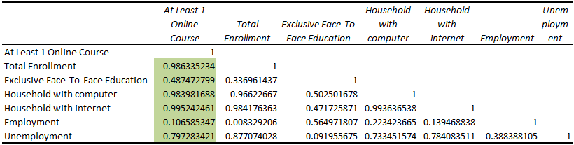

1. **Top 10 states in using e-learning and top 10 states in less using of e-learning.**
2. **Top 10 State B. Bottom 10 State**

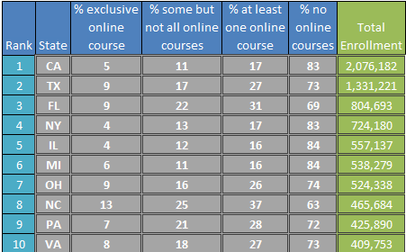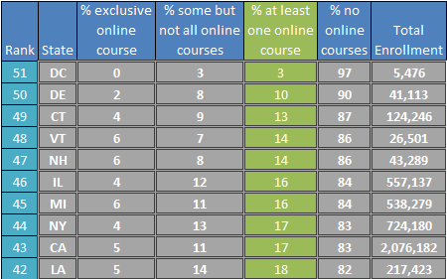

1. **What happens during recession?**

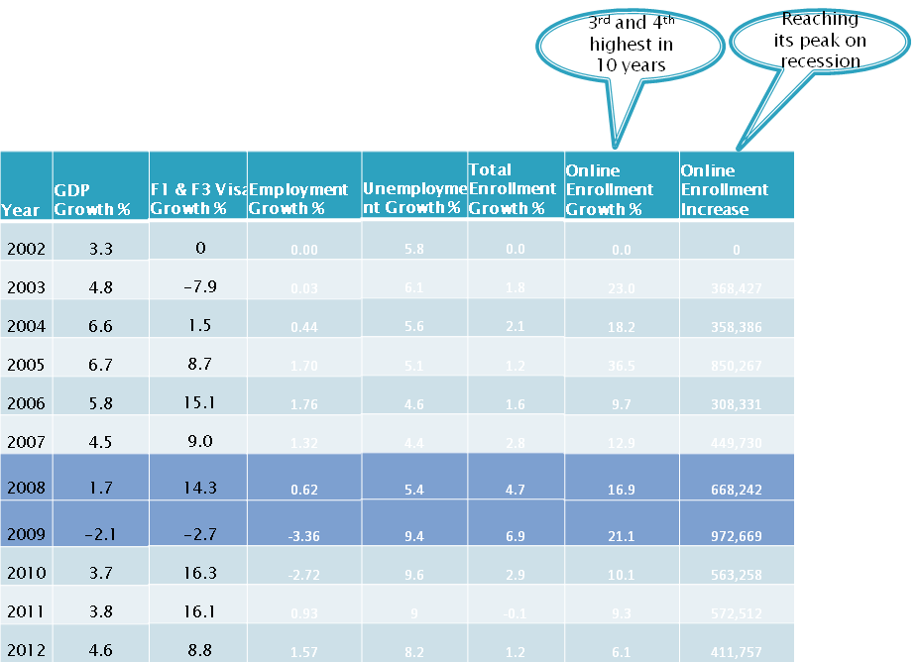

**Economic performance & Online Education**

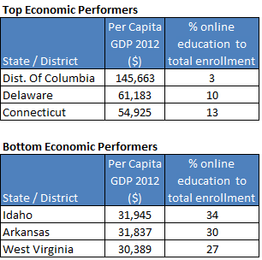

1. **International Students Enrollment**

We studies international students enrollment from two developed countries(Canada, Japan)and two developing countries (China, India) from 2006-2012 if we look to the data international students from Japan decreased but from china increased.

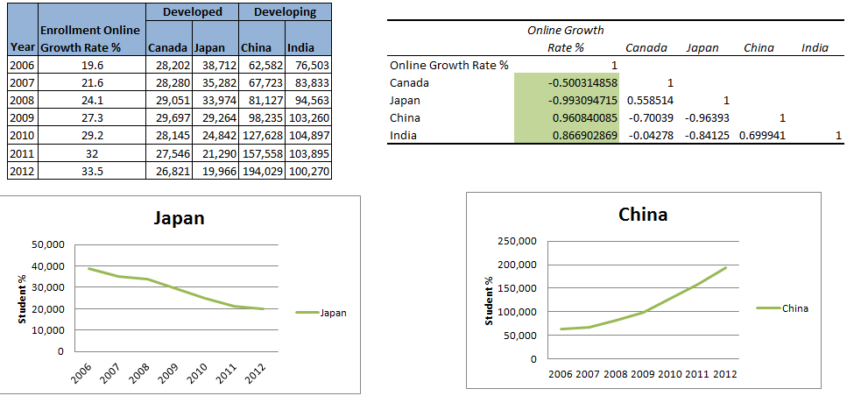

## Projection of online education in near future

## We project the data we have to 2030 and it seems that online education will increase very quickly but it will not affect the traditional education, lots of students will take traditional courses till year 2022 we will see slight decrease in traditional education enrolment and the online education will continue to increase.

## Additional Findings:

* **From the data of DE Enrollment Fall 2012, summarize data of State & Type of Study has a good clustering quality for columns: State, Level and Total Enrollment**

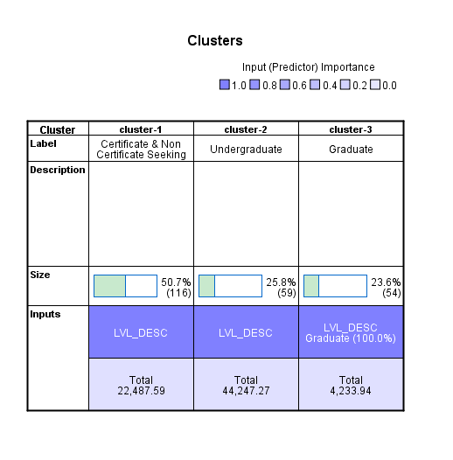

The result that we found was, from the 229 rows of data, 50.7 % was Certificate & Non Certificate seeking people, with the average of 22,487 enrollments in the whole USA. While 25.8 % was undergraduate level and 23.6% was graduate level.

## Part VI

## Conclusion/Limitation

## Conclusion

* Traditional face-to-face Education

Online Education has an impact but it will not replace face-to-face education in the future.

* Economic Development
  + Online Education and economic growth have a certain degree of relationship. Where there is less economic growth people are opting for online education as means for gaining education.
* Enrollment Number of International Students
  + Online Education has impact on international students from developed countries like Canada, Japan, etc. As their total enrolment keeps on decreasing.
* Employment/Unemployment Rate
  + Fall in employment is corresponding with increase in online education.
* Increase of Internet Use at Home
  + Technology is the most significant factor that is contributing to online education. Not only household computers & internet connection but also mobiles & wireless connectivity are contributing to growth in Online Education.

In conclusion, Online Enrollment always outstripping the other variables because:

* Affordable 🡪 cheaper or even free.
* Accessible 🡪 very convenient and can access it anytime anywhere.
* Access for rural & disabled student.
* Sustainable.
* On pace with the Future Education.
* Irrespective of age, background, etc.
* People can get education while being employed.

## Do you believe Online Education will replace Face-to Face Education?

## What did the experts say?

## 

I believe that MOOCs will not replace traditional campus-based learning. Instead, they may reach the newly forming markets of just-in-time learners, job-credentialing and skills-updating.

Those who can afford it will continue to pursue the traditional campus-based learning. Those who can't will choose among MOOC and other online-learning opportunities that are more affordable and flexible.

Already at my campus very nearly 45% of the credit hours are earned in online classes; more than one-third of the students did not come to campus, choosing instead to take only online courses.

No, I Don’t

But far and away the most important effect of online education will be to bring in people who aren't part of the current educational system at all, from people with degrees and jobs using them for retraining (which we already see a lot of) to people who could never have afforded an M.S. in computer science now [being] able to get one from Georgia Tech for less than $7,000.

* **What did we say?**

We believe that Online Course will not replace face-to-face Education because there’s just some things you can’t get in online education, such as :

* The school experience and class interaction
* Since online course is cheap or even free, some student of online course didn’t finish the course, and they changed course a lot of time.
* No certificates, or sometimes the online course certificates are not trusted.

However, we believe that Online Education will change the face of education and the number of educated people all around the world. There might be a lot of really smart people out there that can not continue their education because they don’t have money or they must work to make a living for their family. With Online Education they can continue their education while making their living which only costs the price of internet connection.

We believe this will help a lot of people and might even change the world.

## Limitation

Since Online Education has a wide variety of scope, we limit our research for Online Education in US only and not globally. There might also lots of implications but for this study, we only focus for the: economy, international student enrollment, employment/unemployment rate and internet use at home.

Others variables that are not included are:

* Data about the measurement of the quality of online education.
* Cost Saving for online education courses compared to those traditional face-to-face education.
* The success rate of online degree holders on how they get hired and how employers prefer them over the traditional degree holders.

## Part VII

## Option for Future Research

Future research about Online Education can reveal lots of angles to discover more about the significant number and impact of this type of education. Here are some of the options for future research:

* Go Global - explore other countries in terms of Online Education and its impact.
* Cost Savings – – figure out the saving in expenses for online education courses compared to traditional face-to-face education.
* Environmental Impact – evaluate the reduction and savings in carbon emissions and environmental impact of online education system.
* Success Rate – research how many online degree holders get hired and how employers prefer them over the traditional degree holders.

Part VIII

## Relationship with Science of Creative Intelligence

* Creative Intelligence is holistic and it contains the wholeness of life. Taking care of this field will enrich our life, in Business intelligence the “Data” generated contains the wholeness about the business and when we care about it then analyze it, we will come up with interesting knowledge that will enrich and improve the business.
* Creative Intelligence is highly selective. This can be related to data mining when we want to mine the data – we will prepare it first and select the proper instances.
* Creative Intelligence promotes the use of the full potential of our mind. Data mining is about analyzing the data so we can use the full potential of this data and its power in changing and improving business.
* One of the characteristic of Creative Intelligence is purification of the path which is the removal of impediments to progress. This relates to data mining when we prepare the data and cleanse it. We remove duplicates and outlier so that we can have high quality data that help us to progress in the analysis.
* Practice of Transcendental Meditation technique is about choosing the right angle and then letting it go. Like the data mining you first have to understand the business then choose the right angle – the right question that is interesting to you then go and start analysis.